Tutorial Name
Towards a decentralised Federated Learning based edge-to-edge Continuum Computing framework.
Abstract
The proliferation of sensing device technologies, and the growing demand for data intensive IoT applications, are paving the way to the next wave of transformation in IoT computing systems architecture. The goal today is to design, implement and deploy a seamless interconnection of IoT, edge and cloud resources in one computing system, to form a compute continuum, also referred to as edge-to-cloud.
In this tutorial, compute continuum refers to the deployment and execution of context-aware machine learning-based applications employing IoT sensors. Because of their distributed nature over constrained resources devices, these applications leverage the cloud infrastructure for learning tasks while exploiting edge devices for inference tasks on data coming from local IoT sensors. But the next wave of development is already underway. It consists of improving the intelligence of the edge devices by introducing peer-to-peer learning between the edges themselves.
This tutorial presents the architecture of edge-to-cloud solutions offered in industry, as well as the edge-to-edge architectures being developed in R&D.
Name & affiliation
Nabil Abdennadher, nabil.abdennadher@hesge.ch, University of applied Sciences and Arts, Western Switzerland (HES-SO)
Intended audience
PhD Students, engineers, scientists, industrials, and researchers interested in edge-to-cloud IoT applications/platforms, deployment, and development of IoT applications.
Prerequisite knowledge or skills required for attendees
- Cloud basic knowledge
- Python
Expected duration
Half-day
Detailed description
The proliferation of sensing device technologies, and the growing demand for data intensive IoT applications, are paving the way to the next wave of transformation in IoT computing systems architecture. The goal today is to design, implement and deploy a seamless interconnection of IoT, edge and cloud resources in one computing system, to form a compute continuum, also referred to as edge-to-cloud.
In this tutorial, compute continuum refers to the deployment and execution of context-aware machine learning-based applications employing IoT sensors. Because of their distributed nature over constrained resources devices, these applications leverage the cloud infrastructure for learning tasks while exploiting edge devices for inference tasks on data coming from local IoT sensors. But the next wave of development is already underway. It consists of improving the intelligence of the edge devices by introducing peer-to-peer learning between the edges themselves.
But the next wave of development is already underway; it will involve designing edge-to-edge communication to enable learning takes place locally. A coordination platform is used to exchange intelligence between the edges. Unlike edge-to-cloud platforms, where learning takes place centrally in the cloud, edge-to-edge communication will enable decentralised learning approaches based on Federated Learning (FL).
This tutorial is divided into two parts. The first deals with the edge-to-cloud solutions available in industry. We explore four platforms: AWS Amazon, Google, MS Azure and Nuvla/NuvlaEdge. In these platforms, learning takes place in the cloud, while inference (Machine Learning Model: MLM) is performed on the edge (Figure 1). The intelligence (MLM) of the edge is controlled by the cloud. There is no communication between the edges. The deployment of MLMs on the edge devices roughly follows several standard steps: The IoT application generates an initial MLM from a set of training data. The MLM is then deployed through the platform. The performance of the deployed MLM is continuously monitored: each time the MLM is unable to take a reliable decision, it sends the data it failed to process to the cloud. The cloud then collects these datasets from different edge devices and triggers a new learning cycle, resulting in a new MLM which will then be pushed back to the edge devices.
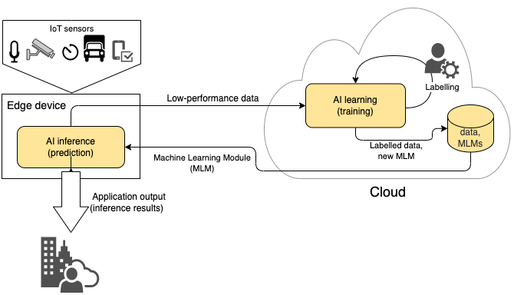
Figure 1: Edge-to-Cloud solutions for context-aware applications
The second part proposes an approach to develop a coordination framework where the edge devices communicate together to improve their intelligence (Figure 2). Here, each edge can generate its own MLM (training) and communicate with its neighbours to improve its intelligence (MLM). An aggregation module aggregates the MLMs of its “neighbours”. In this context, the neighbourhood concept is important ; it will be described in more detail below.

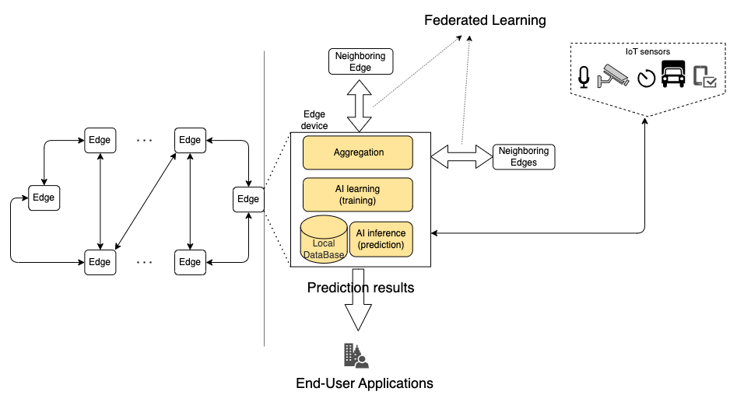
Figure 2: Edge-to-edge architecture for context-aware applications
Part 1: Edge-to-Cloud solutions (Centralised continuum computing platforms)
The theoretical part presents a comparative study of four technologies used to develop and deploy context-aware Machine Learning (ML) based IoT applications on continuum computing platforms (edge-to-cloud solutions). The four technologies are: AWS IoT Greengrass, Azure IoT Edge, Google, and Nuvla/NuvlaEdge. The comparative study focuses on three levels:
- Service level: tools needed to deploy context-aware Machine Learning based IoT applications on edge-to-cloud solutions. The goal here is to give an unbiased overview of what is available from each provider.
- Application level: To compare the five solutions from an application-level perspective, we consider the following criteria: licensing model, hosting model, hardware support, documentation quality, integration (interoperability, components on premises, orchestration, monitoring, logging and telemetry, security (end-to-end encryption, identity and access management: IAM, controlled commissioning) and risks (Vendor lock-in, Security breaches, fault tolerance and resilience)
- Operating costs level: The goal here is to compare the operating costs related to the deployment of a given context-aware application on the five continuum computing technologies detailed above. The comparative study relies on a generic cost model composed of five sub-models which model five costs (1) edge devices registration, (2) exchanged messages, (3) storage operations, (4) data transfers and (5) computation.
The practical part of this chapter includes one demo and one practical exercise:
- The demo consists of deploying a “hello world” application on the edge-to-cloud solution of MS Azure: an edge device (Raspberry Pi) equipped with a camera runs software that recognizes objects. If it fails, the edge module sends the image to the Cloud. The cloud collects the images not recognized by the edge and launches a new learning phase to generate a new model (MLM) that will be uploaded to the cloud.
- The practical exercise will enable participants to deploy a ML based application on an open-source edge-to-cloud platform: Nuvla.io/NuvlaEdge. The edge devices are simulated by VMs deployed on AWS Amazon AWS. To this purpose, participants will have AWS accounts enabling them to create their own “Virtual edge devices”
Part 2: Towards an edge-to-edge framework (or: Towards a decentralised Continuum Computing framework)
The theoretical part of this chapter (Part 2) presents two peer-to-peer (edge-to-edge) decentralised federated learning algorithms where the edge intelligence is improved through a peer-to-peer communications among the neighbours’ edges.
This part addresses the following five questions:
- With whom does an edge exchange to improve its performance? (Neighbourhood concept)
- What metrics should be used to define the neighbourhood concept?
- When and how does an edge update its neighbours?
- When and how should the configuration of the local neural network (intelligence) be modified?
- When does a new training should be carried out?
The practical part of this chapter includes four exercises:
- A skeleton of a distributed algorithm that will later be used for decentralised federated learning (see point 4 below). This algorithm, written in python, will be locally deployed.
- Bulk deployment: the goal here is to create a set of Virtual Edge devices (AWS Amazon VMs) that will be used for the next exercises (points 3 and 4). Concretely speaking, the participants will use Ansible to create a set of Virtual Edge devices: VMs on AWS Amazon infrastructure (as explained in the exercise of Part 1).
- Deployment of the decentralised algorithm of point 1 on the virtual edge devices infrastructure created in point 2. In this exercise, participants will use Kubernetes and SWARM docker compose to deploy the distributed algorithm.
- A decentralised federated learning algorithm. In this exercise, the decentralised algorithm deployed locally (point 1) and on an edge-to-edge infrastructure (point 3) will be enhanced by a ML learning algorithm (Figure 2): distributed federated learning. The participants will have to answer the five questions mentioned above in the concrete case of an electrical energy consumption prediction application. Real household data will be used for this purpose.
Tools used in the tutorial:
- AWS Amazon infrastructure: accounts will be created by the organiser
- Docker, Kubernetes, Ansible, Python: to be installed by the participants on their own laptops or VMs (Instructions will be sent to participants before the tutorial).

Previous offerings of the tutorial
The organiser has already given a tutorial in MECO conference related to part 1 (edge-to-cloud platforms). Part 2 has never been proposed.
Curriculum vitae of the presenter
See detail on: https://lsds.hesge.ch/nabil-abdennadher/
Originally from the high-performance computing community, Nabil Abdennadher worked on methodologies and tools to develop and deploy e-Science applications on large scale distributed systems. He has in his active 33 approved research projects (see details on http://lsds.hesge.ch/projects/). These projects are in the following IT research areas: High Performance Computing, Parallel and Distributed Computing, Edge and Cloud Computing, Internet of Things, Urban Computing, Trust Computing, context-aware Applications. They target several application domains such as renewable energies and smart grid, smart city, climate, medicine, environment, biotechnology, art, agriculture, learning and teaching, agriculture.
Nabil Abdennadher is responsible for several main courses that cover bachelor (undergraduate) and master (graduate) levels at University of Applied Sciences, Western Switzerland: HES-SO:
- Distributed Systems (bachelor) and Parallel & Distributed Systems (Master)
- Cloud & Deployment (bachelor) and Cloud Services & Systems (Master)
- Internet of Things (Master)
- Academic Writing and Presentation (Master)

